Olvana Ground Forces - Force Structure Modifications

James Stevenson, TRADOC G-2 Analyst

To keep the Army’s training environment, the [Decisive Action Training Environment](https://odin.tradoc.army.mil/) (DATE), realistic, relevant, and intelligence-informed, TRADOC G-2 has published a significant update to the military force structure for the DATE country [*Olvana*](https://odin.tradoc.army.mil/DATE/a7f54b856bdda3a8a4666108b3f05c6e)*.* Olvana serves as the pacing threat actor for the DATE Indo-Pacific region. The military organization is heavily influenced by [ATP 7-100.3](https://armypubs.army.mil/ProductMaps/PubForm/Details.aspx?PUB_ID=1023379), *Chinese Tactics*, and deliberately designed to provide a robust peer threat for use in Army training. TRADOC G-2 altered some force structures and associated equipment to better reflect real world adversary organization and capabilities. This update will better enable training events to represent an Indo-Pacific threat training at home stations and in large-scale combat operations (LSCO) exercise environments.

# Comparison of Old vs. New

For echelons above theater army, there were minor changes. Within the Supreme High Command (SHC) assets, the 72nd Tank Division and 73rd Mechanized Divisions were removed to create a more realistic structure for training (see Figure 1). Additionally, the Surface-to-Surface Missile Command, unmanned aerial vehicle (UAV) brigade, and information warfare brigade were shifted to the Strategic Forces Command (see Figure 2). Together, these moves more closely align Olvanan strategic force capabilities with organizations we see in the real world.

Figure 1: Supreme High Command graphic created by U.S. Army TRADOC G-2

Figure 2: Strategic Forces Command graphic created by U.S. Army TRADOC G-2

The major changes between the old and new force structures were made at the theater army level and below. In the new group armies, you will see a mix of six brigades consisting of motorized (MTZD), mechanized (MECH), and armored/amphibious units. Additionally, units that represent key enabling assets at the group army level were adjusted (see Figure 3).

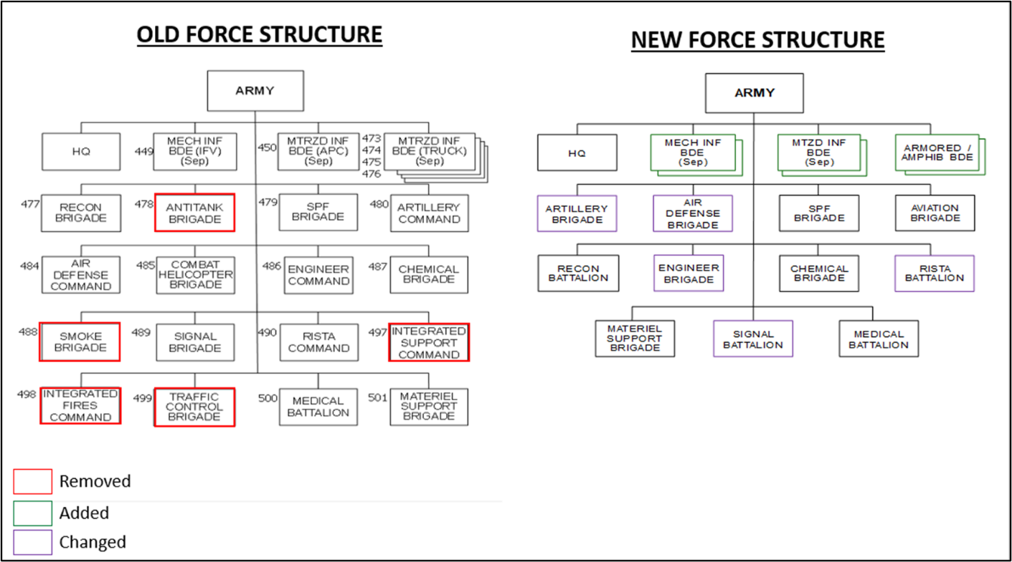

Figure 3: Group Army graphic created by U.S. Army TRADOC G-2

Within the motorized infantry brigades, only minor changes were made to the force structure (see Figure 4). A motorized infantry brigade relies on the CSK-141 and EQ-2050 trucks to move infantry and has a battalion of Type 15 light tanks (see Figure 5). As a combined arms unit, the brigade is also equipped with organic key enablers, including artillery and reconnaissance assets, and key protection enablers like air defense and engineering.

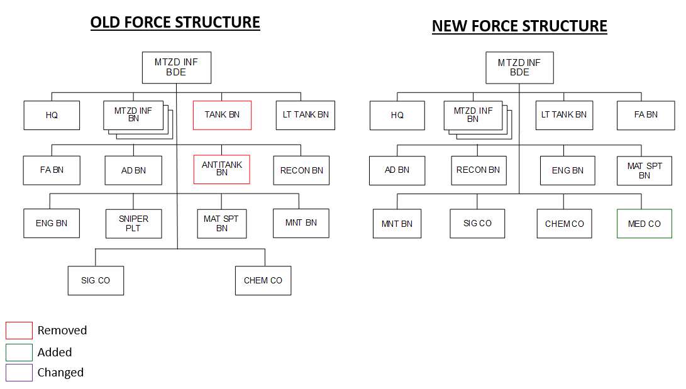

Figure 4: Motorized Infantry Brigade graphic created by U.S. Army TRADOC G-2

|  |  |
| --- | --- |
| **Equipment Type** | **# per BN** |
| [CSK-141](https://odin.tradoc.army.mil/WEG/Asset/Dongfeng_CSK-141_Chinese_4x4_Light_Tactical_Vehicle) | 30 |
| [Type 15 LT TANK](https://odin.tradoc.army.mil/WEG/Asset/ZTQ-15_(Type_15)_Chinese_Light_Main_Battle_Tank_(MBT)) | 42 |
| [PCL-09 SPG](https://odin.tradoc.army.mil/WEG/Asset/PCL-09_Chinese_122mm_Self-Propelled_Howitzer_(SPH)) | 27 |
| [Type 90 MRL](https://odin.tradoc.army.mil/WEG/Asset/PHL-90B_(Type_90B)_Chinese_122mm_Multiple_Rocket_Launcher_(MRL)) | 9 |
| [PG-99](https://odin.tradoc.army.mil/WEG/Asset/PG99_Chinese_35mm_Towed_Anti-Aircraft_Gun) | 18 |
| [FB-6](https://odin.tradoc.army.mil/WEG/Asset/FB-6A_Chinese_4x4_Mobile_Short-Range_Air_Defense_System) | 8 |
| [CSK-141 RECON](https://odin.tradoc.army.mil/WEG/Asset/Dongfeng_CSK-141_Chinese_4x4_Light_Tactical_Vehicle) | 20 |

Figure 5: Primary Equipment List Created by U.S. Army TRADOC G-2

No direct changes were made to the motorized infantry battalions; however, the structure demonstrates how the battalion can be task organized/augmented from brigade if needed to support training objectives (see Figure 6).

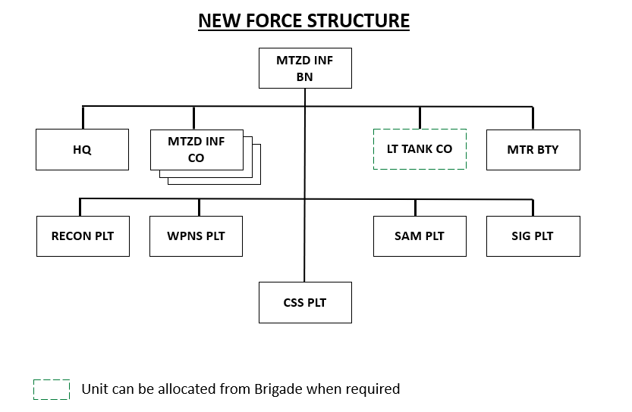

Figure 6: Motorized Infantry Battalion graphic created by U.S. Army TRADOC G-2

|  |  |
| --- | --- |
| **Equipment Type** | **# per CO** |
| [CSK-141](https://odin.tradoc.army.mil/WEG/Asset/Dongfeng_CSK-141_Chinese_4x4_Light_Tactical_Vehicle) | 10 |
| [Type 15 LT TANK](https://odin.tradoc.army.mil/WEG/Asset/ZTQ-15_(Type_15)_Chinese_Light_Main_Battle_Tank_(MBT)) | 14 |
| [SM-1 (81mm) MTR](https://odin.tradoc.army.mil/WEG/Asset/PCP-001_(SM-1)_Chinese_82mm_Self-Propelled_Rapid-Deployment_Mortar) | 9 |
| [CSK-141 RECON](https://odin.tradoc.army.mil/WEG/Asset/Dongfeng_CSK-141_Chinese_4x4_Light_Tactical_Vehicle) | 3 |

Figure 7: Primary Equipment List Created by U.S. Army TRADOC G-2

Within the mechanized infantry brigades, changes consisted of removing the tank battalions, antitank battalion, and the sniper platoon and adding a mechanized battalion (see Figure 8). A mechanized brigade relies on wheeled armored personnel carriers to move infantry. As a combined arms unit, the brigade is also equipped with organic key enablers, including artillery and reconnaissance assets as well as key protection enablers like air defense and engineering.

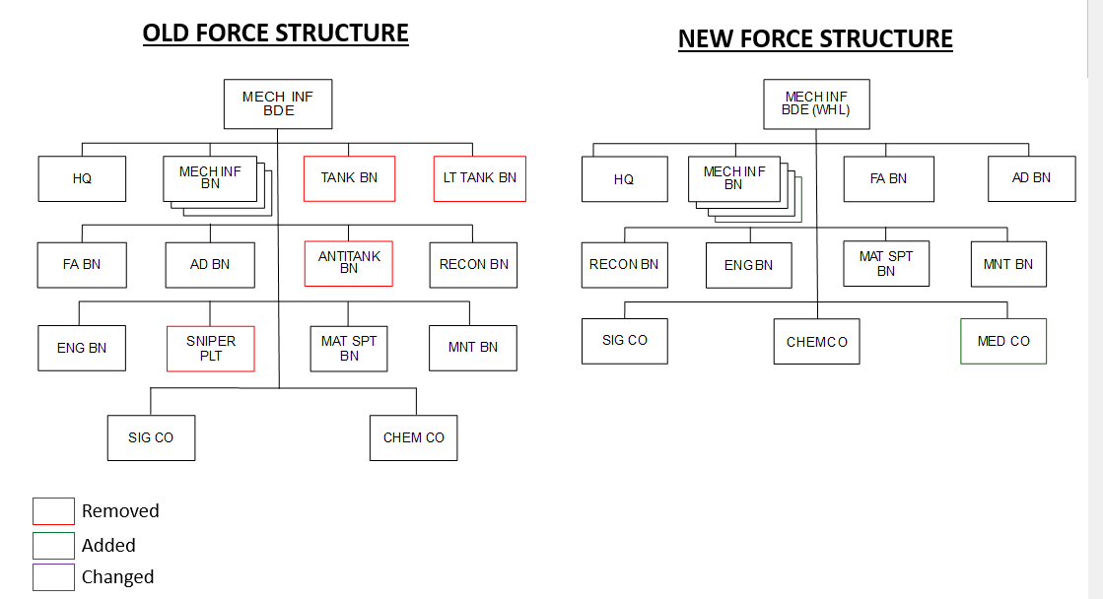

Figure 8: Mechanized (Wheel) Infantry Brigade graphic created by U.S. Army TRADOC G-2

|  |  |
| --- | --- |
| **Equipment Type** | **# per BN** |
| [ZBL-08](https://odin.tradoc.army.mil/WEG/Asset/ZBL-08_(Type_08)_Chinese_8x8_Infantry_Fighting_Vehicle_(IFV)) | 30 |
| [PLL-09 SPG](https://odin.tradoc.army.mil/WEG/Asset/PLL-09_(Type_09)_Chinese_122mm_Self-Propelled_Howitzer_(SPH)) | 27 |
| [Type 90B MRL](https://odin.tradoc.army.mil/WEG/Asset/PHL-90B_(Type_90B)_Chinese_122mm_Multiple_Rocket_Launcher_(MRL)) | 9 |
| [ZBL-09 35mm AA](https://odin.tradoc.army.mil/WEG/Asset/ZZH-09_(Type_09)_Chinese_8x8_Amphibious_Armor_Personnel_Carrier_(APC)) | 18 |
| [HQ-17A](https://odin.tradoc.army.mil/WEG/Asset/HQ-17A_(FM-2000)_Chinese_Short-Range_Air_Defense_Missile_System) | 8 |
| [ZBL-08 RECON](https://odin.tradoc.army.mil/WEG/Asset/ZBL-08_(Type_08)_Chinese_8x8_Infantry_Fighting_Vehicle_(IFV)) | 20 |

Figure 9: Primary Equipment List Created by U.S. Army TRADOC G-2

The major change made to the mechanized infantry battalion was the addition of an antitank company equipped with the ZTL-11, a wheeled 105-mm assault gun; this change allows the battalion to have additional firepower during operations against a heavier opponent (see Figures 10 and 11).

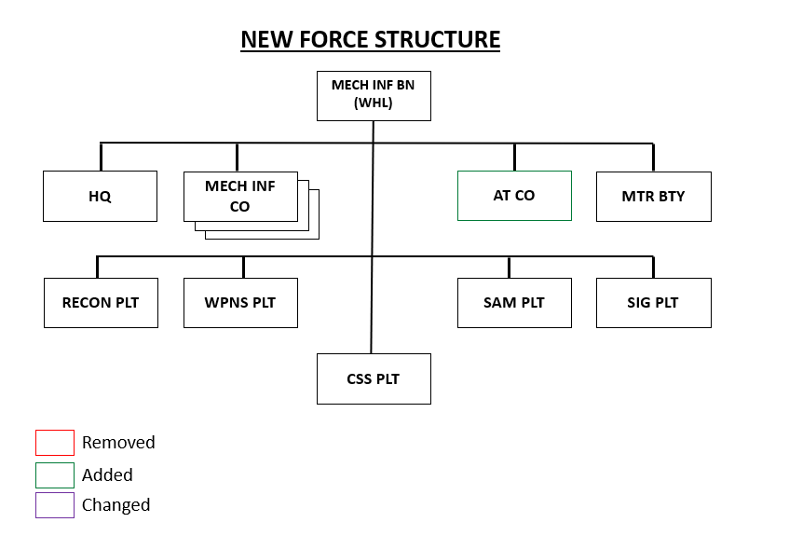

Figure 10: Mechanized (Wheel) Infantry Battalion graphic created by U.S. Army TRADOC G-2

|  |  |
| --- | --- |
| **Equipment Type** | **# per CO** |
| [ZBL-08](https://odin.tradoc.army.mil/WEG/Asset/ZBL-08_(Type_08)_Chinese_8x8_Infantry_Fighting_Vehicle_(IFV)) | 10 |
| [ZTL-11](https://odin.tradoc.army.mil/WEG/Asset/ZTL-11_(Type_11)_Chinese_8x8_Armored_Fighting_Vehicle) | 14 |
| [PLL-05 (120mm) MTR](https://odin.tradoc.army.mil/WEG/Asset/PLL-05_(Type_05)_Chinese_120mm_Self-Propelled_Mortar) | 9 |
| [ZBL-08 RECON](https://odin.tradoc.army.mil/WEG/Asset/ZBL-08_(Type_08)_Chinese_8x8_Infantry_Fighting_Vehicle_(IFV)) | 3 |

Figure 11: Primary Equipment List Created by U.S. Army TRADOC G-2

Within the armored brigades, changes consisted of the removal of the mechanized battalion, leaving four armored battalions. Additionally, the reconnaissance and material support units have changed from companies to battalions (see Figure 12). This change was done to create a more realistic peer threat that could be seen on the battlefield. The armored brigade relies on infantry fighting vehicles (IFVs) to move infantry and has additional tanks within the battalions. As a combined arms unit, the brigade is also equipped with organic key enablers including artillery and reconnaissance assets and key protection enablers like air defense and engineering.

Figure 12: Armored Brigade graphic created by U.S. Army TRADOC G-2

|  |  |
| --- | --- |
| **Equipment Type** | **# per BN** |
| [ZBD-04](https://odin.tradoc.army.mil/WEG/Asset/ZBD-04_(Type_04)_Chinese_Amphibious_Infantry_Fighting_Vehicle_(IFV)) | 20 |
| [ZTZ-96](https://odin.tradoc.army.mil/WEG/Asset/ZTZ-96_(Type_96)_Chinese_Main_Battle_Tank_(MBT)) | 28 |
| [PLZ-07 (122mm)](https://odin.tradoc.army.mil/WEG/Asset/PLZ-07_(Type_07)_Chinese_122mm_Self-Propelled_Howitzer_(SPH)) | 27 |
| [PHZ-11 MRL](https://odin.tradoc.army.mil/WEG/Asset/PHL-11_Chinese_122mm_Multiple_Launch_Rocket_System_(MLRS)) | 9 |
| [PGZ-09](https://odin.tradoc.army.mil/WEG/Asset/PGZ-09_(Type_07)_Chinese_35mm_Self-Propelled_Anti-Aircraft_Gun) | 18 |
| [HQ-17A](https://odin.tradoc.army.mil/WEG/Asset/HQ-17A_(FM-2000)_Chinese_Short-Range_Air_Defense_Missile_System) | 8 |
| [ZBD-04 RECON](https://odin.tradoc.army.mil/WEG/Asset/ZBD-04_(Type_04)_Chinese_Amphibious_Infantry_Fighting_Vehicle_(IFV)) | 20 |

Figure 13: Primary Equipment List Created by U.S. Army TRADOC G-2

The major change made to the armored battalion was an increase in the number of tanks to 14 per company. An additional change was having four companies split evenly between tanks and IFVs. (see Figure 14).

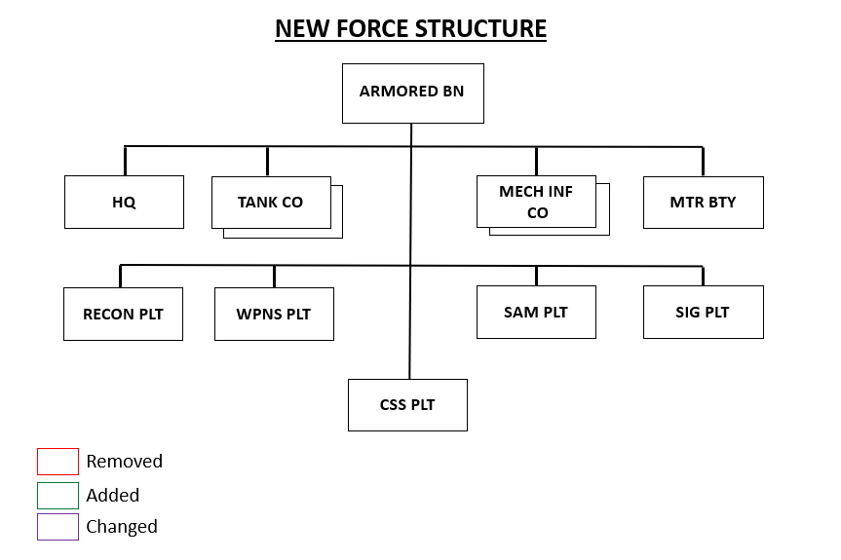

Figure 14: Armored Battalion graphic created by U.S. Army TRADOC G-2

|  |  |
| --- | --- |
| **Equipment Type** | **# per CO** |
| [ZBD-04](https://odin.tradoc.army.mil/WEG/Asset/ZBD-04_(Type_04)_Chinese_Amphibious_Infantry_Fighting_Vehicle_(IFV)) | 10 |
| [ZTZ-96](https://odin.tradoc.army.mil/WEG/Asset/ZTZ-96_(Type_96)_Chinese_Main_Battle_Tank_(MBT)) | 14 |
| [PLZ-10 (120mm) MTR](https://odin.tradoc.army.mil/WEG/Asset/PLZ-10_(Type_05A)_Chinese_120mm_Self-Propelled_Mortar) | 9 |
| [ZBD-04 RECON](https://odin.tradoc.army.mil/WEG/Asset/ZBD-04_(Type_04)_Chinese_Amphibious_Infantry_Fighting_Vehicle_(IFV)) | 3 |

Figure 15: Primary Equipment List Created by U.S. Army TRADOC G-2

The amphibious brigades are identical in design to the armored brigades, with only the equipment being different between the two (see Figure 16). The equipment changes were the IFVs switching from ZBD-04s to ZBD-05s, and the tanks from ZTZ-96s to ZTD-05s (see Figure 17).

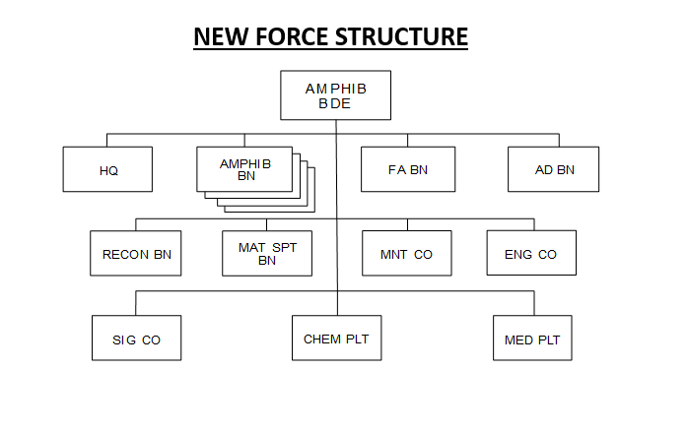

Figure 16: Amphibious Brigade graphic created by U.S. Army TRADOC G-2

|  |  |
| --- | --- |
| **Equipment Type** | **# per BN** |
| [ZBD-05](https://odin.tradoc.army.mil/WEG/Asset/ZBD-05_(VN-18)_Chinese_Amphibious_Infantry_Fighting_Vehicle_(IFV)) | 20 |
| [ZTD-05](https://odin.tradoc.army.mil/WEG/Asset/ZTD-05_(VN-16)_Chinese_Amphibious_Light_Tank) | 28 |
| [PLL-09](https://odin.tradoc.army.mil/WEG/Asset/PLL-09_(Type_09)_Chinese_122mm_Self-Propelled_Howitzer_(SPH)) | 27 |
| [PHZ-11 MRL](https://odin.tradoc.army.mil/WEG/Asset/PHL-11_Chinese_122mm_Multiple_Launch_Rocket_System_(MLRS)) | 9 |
| [PGZ-09](https://odin.tradoc.army.mil/WEG/Asset/PGZ-09_(Type_07)_Chinese_35mm_Self-Propelled_Anti-Aircraft_Gun) | 18 |
| [HQ-7](https://odin.tradoc.army.mil/WEG/Asset/HQ-7_(FM-80)_Chinese_Short-Range_Air_Defense_Missile_System) | 8 |
| [ZBD-05 RECON](https://odin.tradoc.army.mil/WEG/Asset/ZBD-05_(VN-18)_Chinese_Amphibious_Infantry_Fighting_Vehicle_(IFV)) | 20 |

Figure 17: Primary Equipment List Created by U.S. Army TRADOC G-2

The changes at the battalion level are the same as described in the amphibious brigade. Only the type of equipment changed (see Figures 18 and 19).

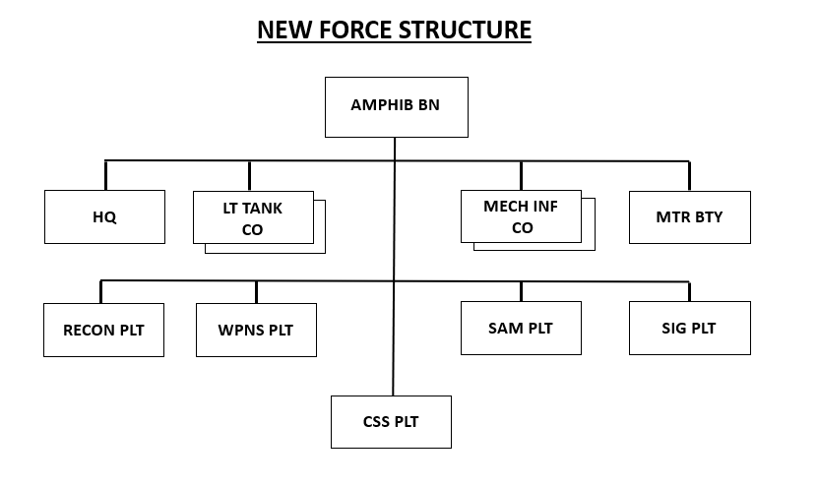

Figure 18: Amphibious Battalion graphic created by U.S. Army TRADOC G-2

|  |  |
| --- | --- |
| **Equipment Type** | **# per CO** |
| [ZBD-05](https://odin.tradoc.army.mil/WEG/Asset/ZBD-05_(VN-18)_Chinese_Amphibious_Infantry_Fighting_Vehicle_(IFV)) | 10 |
| [ZTD-05](https://odin.tradoc.army.mil/WEG/Asset/ZTD-05_(VN-16)_Chinese_Amphibious_Light_Tank) | 14 |
| [PLZ-10 (120mm) MTR](https://odin.tradoc.army.mil/WEG/Asset/PLZ-10_(Type_05A)_Chinese_120mm_Self-Propelled_Mortar) | 9 |
| [ZBD-05 RECON](https://odin.tradoc.army.mil/WEG/Asset/ZBD-05_(VN-18)_Chinese_Amphibious_Infantry_Fighting_Vehicle_(IFV)) | 3 |

Figure 19: Primary Equipment List Created by U.S. Army TRADOC G-2

The major change for artillery is that it downsized from a command to a brigade in size and the units within from brigades to battalions, this is to provide a more realistic portrayal of peer threats. The changes also consisted of removing one artillery battalion but adding both a heavy and light multiple-rocket launcher (MRL) battalion, as well as a UAV company. Following the artillery brigade chart (see Figure 20) are the three different battalion organizations: one for the artillery brigade, one for a motorized/mechanized brigade, and one for an armored/amphibious brigade.

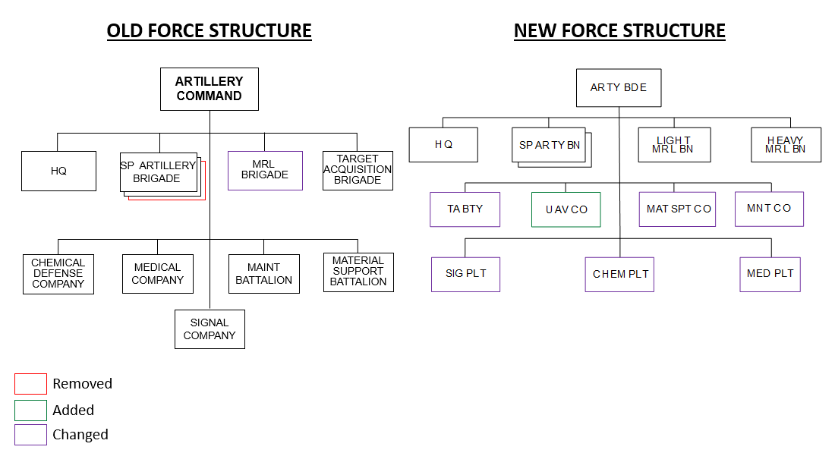

Figure 20: Artillery Brigade graphic created by U.S. Army TRADOC G-2

|  |  |
| --- | --- |
| **Equipment Type** | **# per BN** |
| [PLZ-05 (155mm)](https://odin.tradoc.army.mil/WEG/Asset/PLZ-05_(Type_05)_Chinese_155mm_Self-Propelled_Howitzer_(SPH)) | 18 |
| [PHL-09B MRL](https://odin.tradoc.army.mil/WEG/Asset/PHL-90B_(Type_90B)_Chinese_122mm_Multiple_Rocket_Launcher_(MRL)) | 27 |
| [PHL-16 MRL](https://odin.tradoc.army.mil/WEG/Asset/PHL-16_(PCL-191)_Chinese_370mm_Multiple_Rocket_Launcher_System) | 12 |
| [ASN-209 UAV](https://odin.tradoc.army.mil/WEG/Asset/ASN-209_Chinese_Reconnaissance_Unmanned_Aerial_Vehicle_(UAV)) | 4 |

Figure 21: Primary Equipment List Created by U.S. Army TRADOC G-2

As shown in the chart below (see Figure 22), the artillery battalion within the artillery brigade has six 155-mm tubes per battery (see Figure 23).

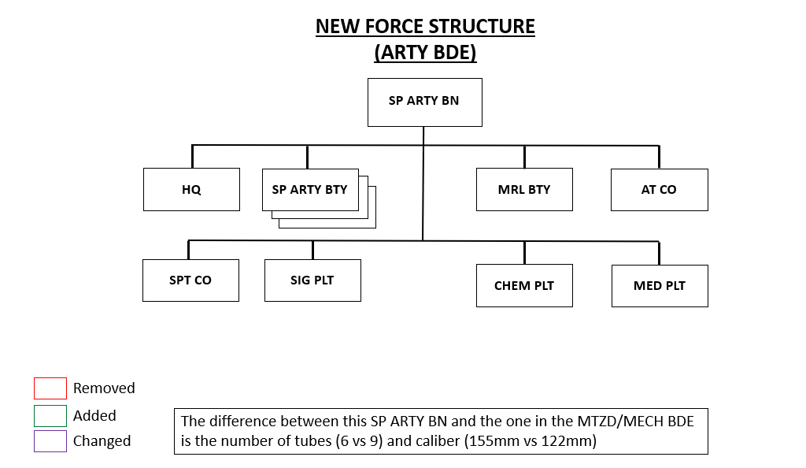

Figure 22: SP Artillery Battalion (Artillery Brigade) graphic created by U.S. Army TRADOC G-2

|  |  |
| --- | --- |
| **Equipment Type** | **# per BTY** |
| [PLZ-05 (155mm)](https://odin.tradoc.army.mil/WEG/Asset/PLZ-05_(Type_05)_Chinese_155mm_Self-Propelled_Howitzer_(SPH)) | 6 |
| [PHL-09B MRL](https://odin.tradoc.army.mil/WEG/Asset/PHL-90B_(Type_90B)_Chinese_122mm_Multiple_Rocket_Launcher_(MRL)) | 9 |
| [ZTL-11](https://odin.tradoc.army.mil/WEG/Asset/ZTL-11_(Type_11)_Chinese_8x8_Armored_Fighting_Vehicle) | 9 |

Figure 23: Primary Equipment List Created by U.S. Army TRADOC G-2

The artillery battalion within the motorized/mechanized brigade has nine 122-mm tubes per battery (see Figures 24 and 25).

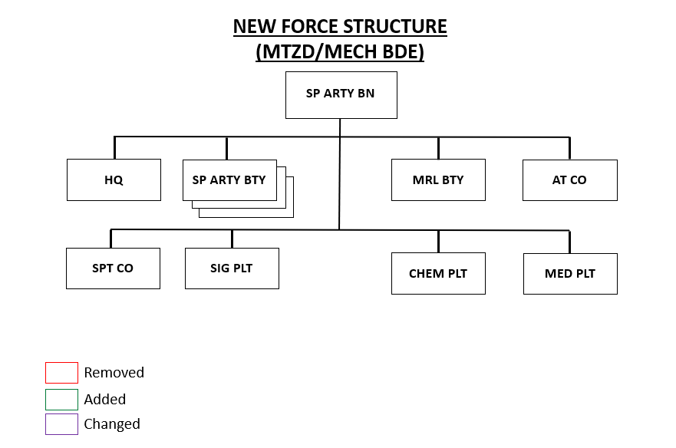

Figure 24: SP Artillery Battalion (MTZD/MECH Brigade) graphic created by U.S. Army TRADOC G-2

|  |  |
| --- | --- |
| **Equipment Type** | **# per BTY** |
| [PLL-09 (122mm)](https://odin.tradoc.army.mil/WEG/Asset/PLL-09_(Type_09)_Chinese_122mm_Self-Propelled_Howitzer_(SPH)) | 9 |
| [PHL-90B MRL](https://odin.tradoc.army.mil/WEG/Asset/PHL-90B_(Type_90B)_Chinese_122mm_Multiple_Rocket_Launcher_(MRL)) | 9 |
| [ZTL-11](https://odin.tradoc.army.mil/WEG/Asset/ZTL-11_(Type_11)_Chinese_8x8_Armored_Fighting_Vehicle) | 9 |

Figure 25: Primary Equipment List Created by U.S. Army TRADOC G-2

The artillery battalion within the armored brigade also has nine 155-mm tubes per battery (see Figures 26 and 27).

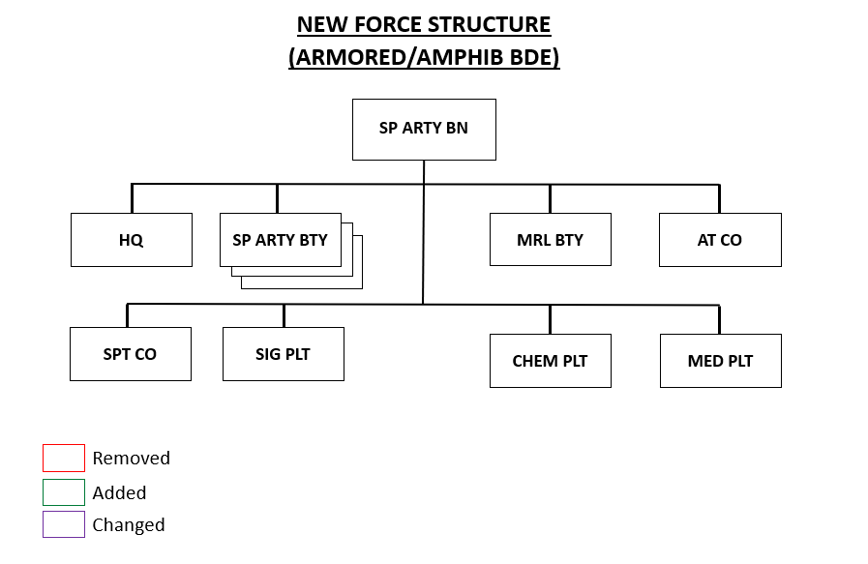

Figure 26: SP Artillery Battalion (ARMORED/AMPHIB Brigade) graphic created by U.S. Army TRADOC G-2

|  |  |
| --- | --- |
| **Equipment Type** | **# per BTY** |
| [PLZ-07 (122mm)](https://odin.tradoc.army.mil/WEG/Asset/PLZ-07_(Type_07)_Chinese_122mm_Self-Propelled_Howitzer_(SPH)) | 9 |
| [PHZ-11 MRL](https://odin.tradoc.army.mil/WEG/Asset/PHL-11_Chinese_122mm_Multiple_Launch_Rocket_System_(MLRS)) | 9 |
| [ZTL-11](https://odin.tradoc.army.mil/WEG/Asset/ZTL-11_(Type_11)_Chinese_8x8_Armored_Fighting_Vehicle) | 9 |

Figure 27: Primary Equipment List Created by U.S. Army TRADOC G-2

The light MRL battalion consists of nine 122-mm MRLs per battery (see Figures 28 and 29).

Figure 28: Light MRL Battalion graphic created by U.S. Army TRADOC G-2

|  |  |
| --- | --- |
| **Equipment Type** | **# per BTY** |
| [PHL-90B MRL](https://odin.tradoc.army.mil/WEG/Asset/PHL-90B_(Type_90B)_Chinese_122mm_Multiple_Rocket_Launcher_(MRL)) | 9 |

Figure 29: Primary Equipment List Created by U.S. Army TRADOC G-2

The batteries within the heavy MRL battalion consist of four MRLs using 370-mm rockets (see Figures 30 and 31).

Figure 30: Heavy MRL Battalion graphic created by U.S. Army TRADOC G-2

|  |  |
| --- | --- |
| **Equipment Type** | **# per BTY** |
| [PHL-16 MRL](https://odin.tradoc.army.mil/WEG/Asset/PHL-16_(PCL-191)_Chinese_370mm_Multiple_Rocket_Launcher_System) | 4 |

Figure 31: Primary Equipment List Created by U.S. Army TRADOC G-2

Air defense units are now brigades, rather than commands, and units within the brigades are battalions. This provides a more realistic portrayal of peer threats. Additional changes include the removal of the long-range battalion and one medium-range battalion, as well as the addition of two short-range battalions and an electronic warfare battalion. Figure 32 depicts the air defense brigade, followed by three different battalion organizations: one each for the medium-range battalion (see Figure 34), the short-range battalion (see Figure 36), and the air defense battalion in a combined arms brigade (see Figure 38).

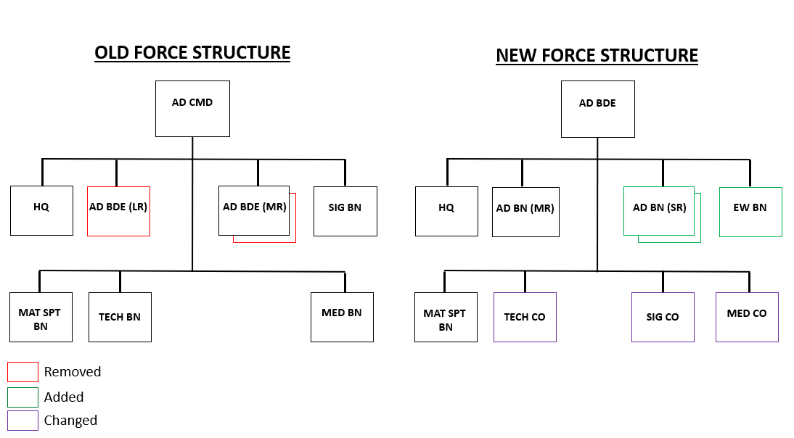

Figure 32: Air Defense Brigade graphic created by U.S. Army TRADOC G-2

|  |  |
| --- | --- |
| **Equipment Type** | **# per BN** |
| [HQ-16](https://odin.tradoc.army.mil/WEG/Asset/HQ-16_(HQ-16A)_Chinese_6x6_Medium-Range_Surface-to-Air_Missile_System) | 9 |
| [PGZ-95](https://odin.tradoc.army.mil/WEG/Asset/PGZ-95_(Type_95)_Chinese_25mm_Self-Propelled_Anti-Aircraft_Vehicle) | 18 |

Figure 33: Primary Equipment List Created by U.S. Army TRADOC G-2

Figure 34: Medium-Range Air Defense Battalion graphic created by U.S. Army TRADOC G-2

|  |  |
| --- | --- |
| **Equipment Type** | **# per BTY** |
| [HQ-16](https://odin.tradoc.army.mil/WEG/Asset/HQ-16_(HQ-16A)_Chinese_6x6_Medium-Range_Surface-to-Air_Missile_System) | 3 |

Figure 35: Primary Equipment List Created by U.S. Army TRADOC G-2

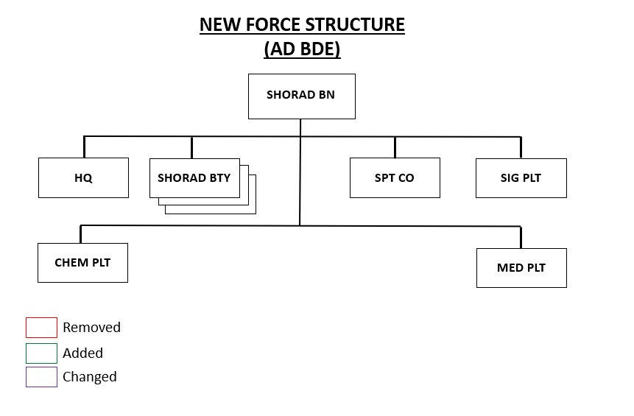

Figure 36: Short-Range Air Defense Battalion graphic created by U.S. Army TRADOC G-2

|  |  |
| --- | --- |
| **Equipment Type** | **# per BTY** |
| [PGZ-95](https://odin.tradoc.army.mil/WEG/Asset/PGZ-95_(Type_95)_Chinese_25mm_Self-Propelled_Anti-Aircraft_Vehicle) | 6 |

Figure 37: Primary Equipment List Created by U.S. Army TRADOC G-2

The biggest change in the combined arms brigade's air defense battalions was the removal of an air defense battery, followed by renaming the unit's self-propelled anti-aircraft guns (SPAAG) and the addition of a SHORAD battery (see Figure 38).

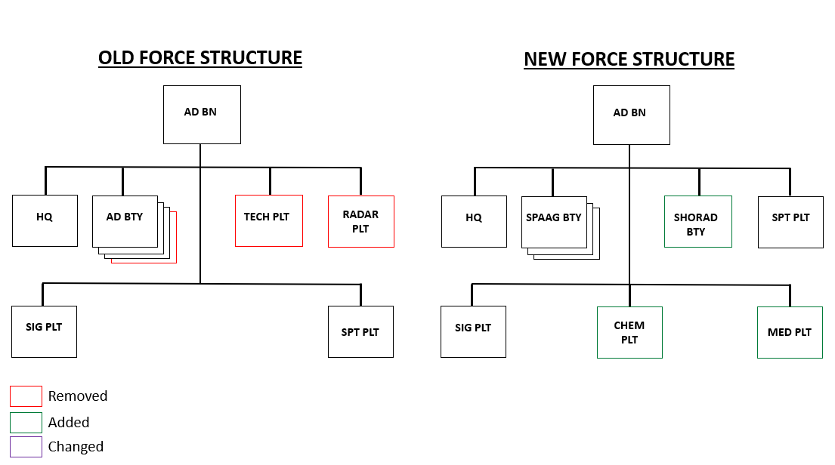

Figure 38: Combined Arms Brigade Air Defense Battalion graphic created by U.S. Army TRADOC G-2

|  |  |
| --- | --- |
| **Equipment Type** | **# per BTY** |
| [PGZ-09](https://odin.tradoc.army.mil/WEG/Asset/PGZ-09_(Type_07)_Chinese_35mm_Self-Propelled_Anti-Aircraft_Gun) | 6 |
| [HQ-7](https://odin.tradoc.army.mil/WEG/Asset/HQ-7_(FM-80)_Chinese_Short-Range_Air_Defense_Missile_System) | 8 |

Figure 39: Primary Equipment List Created by U.S. Army TRADOC G-2

The major change for the aviation brigade was the addition of two utility battalions (see Figure 40). The utility battalions consist of a mixture of Z-20 and Mi-17 helicopters, attack battalions consist of Z-19 helicopters and the recon battalion consist of Z-10 helicopters (see Figure 41).

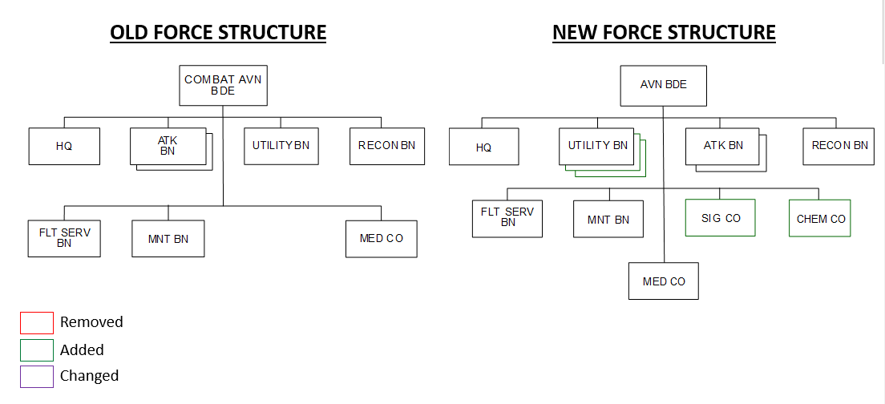

Figure 40: Aviation Brigade graphic created by U.S. Army TRADOC G-2

|  |  |
| --- | --- |
| **Equipment Type** | **# per BN** |
| [Z-20/Mi-17](https://odin.tradoc.army.mil/WEG/Asset/Z-20_Chinese_Medium_Transport_Helicopter) | 12 |
| [Z-10](https://odin.tradoc.army.mil/WEG/Asset/WZ-10_(Z-10)_Chinese_Attack_Helicopter) | 8 |
| [Z-19](https://odin.tradoc.army.mil/WEG/Asset/WZ-19_(Z-19)_Chinese_Reconnaissance::Attack_Helicopter) | 8 |

Figure 41: Primary Equipment List Created by U.S. Army TRADOC G-2

The reconnaissance battalion improvements involve restructuring the present battalion into two reconnaissance companies, a battlefield observation company, a UAV company, and support assets. (see Figure 42).

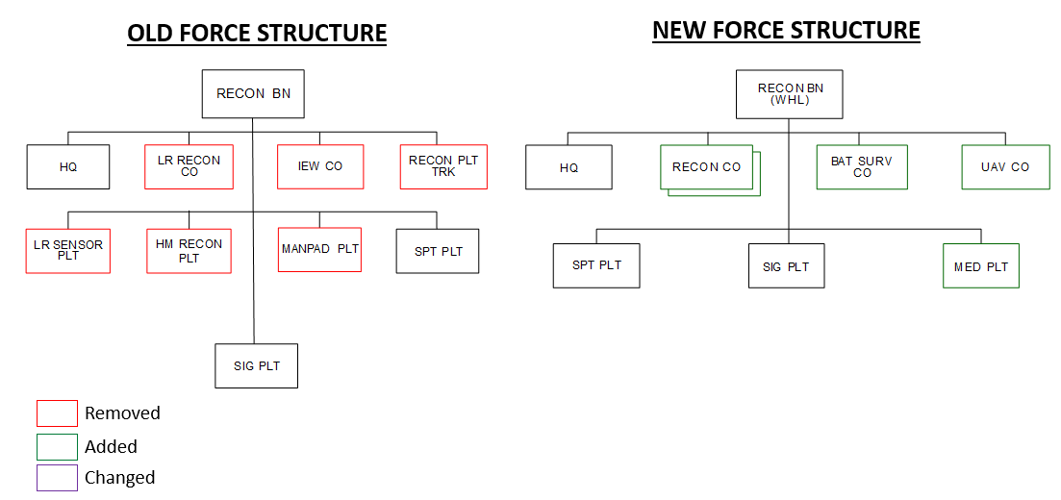

Figure 42: Reconnaissance Battalion graphic created by U.S. Army TRADOC G-2

|  |  |
| --- | --- |
| **Equipment Type** | **# per CO** |
| [CSK-141](https://odin.tradoc.army.mil/WEG/Asset/Dongfeng_CSK-141_Chinese_4x4_Light_Tactical_Vehicle) | 10 |
| [CH-803 UAV](https://odin.tradoc.army.mil/WEG/Asset/CH-803_Chinese_Reconnaissance_Unmanned_Aerial_Vehicle_(UAV)) | 3 |

Figure 43: Primary Equipment List Created by U.S. Army TRADOC G-2

**Conclusion**

The new Olvana ground force structure allows users to develop a robust peer threat for use in training at home station and as part of the train-up for future LSCO exercises. The force structure and corresponding equipment are ever-evolving and will continue to be updated to provide the most capable threat to meet training objectives from commanders at all echelons.

Shortly, TRADOC G-2 will be making additional changes to the Olvana Force Structure that will consist of the following:

* Changes to the Marine Expeditionary Units
* Addition of an Asymmetric Warfare Brigade
* Changes to the Mechanized CABs in the 17th Group Army
* Updates to both the Air Force and Naval Commands
* Changes to the Strategic Forces Command

All of these updates are driven by observations of the operational environment and TRADOC G-2's effort to keep the DATE and Olvana intelligence-informed and able to support representation of a realistic and relevant training threat.

TRADOC G-2 is always open to comments or questions from users. Please fill out this [request form](https://forms.osi.apps.mil/pages/responsepage.aspx?id=D9fm-kuVEUiStgUw1vhMQ3xgsP93S2RAiyNShhxgKGBURTM0UU4zRjhBT1FPQTVIT1BZQzk0R0s3Ri4u) to provide feedback.

References

Army Tactics Publication 7-100.3 Chinese Tactics. August 2021 https://armypubs.army.mil/ProductMaps/PubForm/Details.aspx?PUB_ID=1023379

Training Circular 7-100.4 Hybrid Threat Force Structure Organization Guide. June 2015 https://armypubs.army.mil/epubs/DR_pubs/DR_a/pdf/web/tc7_100x4.pdf